
Cloud Computing Lab
Submitted To:
Sir Shoaib & Sir Waqas

Submitted By:
Hamail Fatima

Roll No:
2023-BSE-023

Section:
5(A)

Lab #04
Task 1 – Verify VM resources in VMware
Confirm the VM resources that were allocated in Lab 1.
Steps
- Open VMware Workstation and locate the Ubuntu Server VM you used in Lab 1.
- Inspect VM settings and note the following (no commands required for GUI): VM name, RAM, CPU, disk, and network adapter type.
- Take a screenshot of the VM settings window showing RAM, CPU, disk and networking. Save screenshot as: vm_settings.png
📸 Screenshot Required:
- vm_settings.png
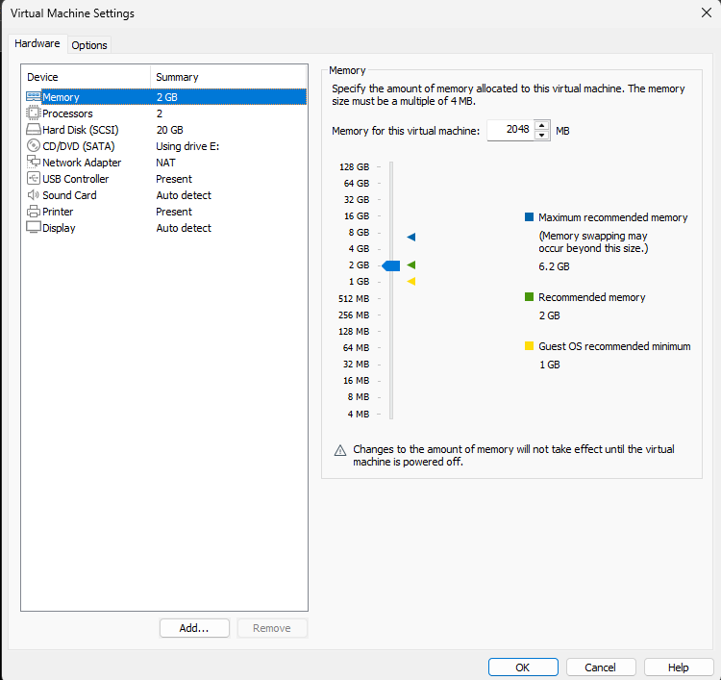

Task 2 – Start VM and log in (use your preferred host terminal method only)
Use a single preferred host-terminal method to connect to the VM. Do not switch between methods during the task.
Steps
- Start (or resume) the VM in VMware Workstation on your host.
- From your host, open your preferred terminal (for example: Windows Command Prompt, PowerShell, macOS Terminal, or Linux Terminal) and connect to the VM using SSH. Example:
ssh student@<vm-ip-address>
- After connecting, save a screenshot of your host terminal showing the SSH login prompt/results as: vm_login.png
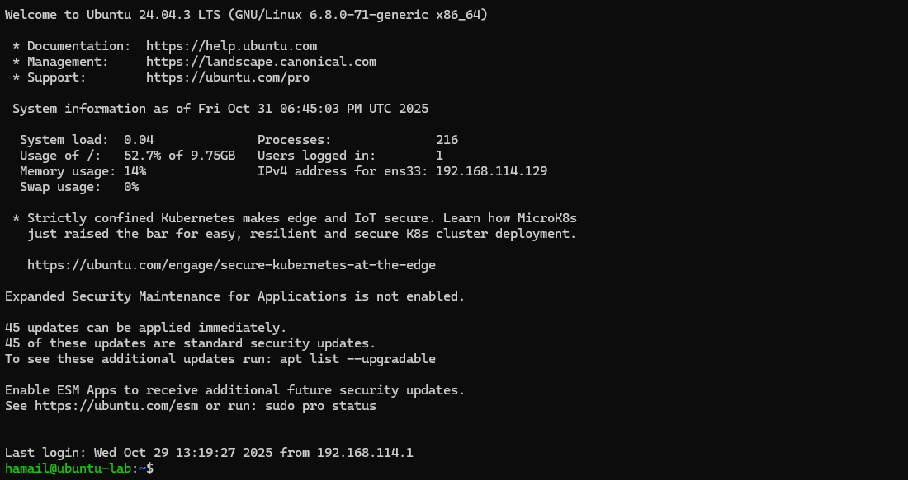
- After logging in, run both commands and capture them together in a single screenshot:
whoami
pwd
- Save a single screenshot that clearly shows both outputs as: whoami_pwd.png
Screenshot Required:
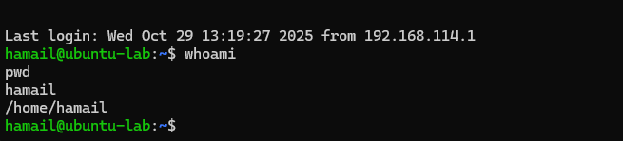
- vm_login.png (optional if whoami_pwd.png provided)
- whoami_pwd.png (required; must show both whoami and pwd outputs)
Task 3 – Filesystem exploration — root tree and dotfiles
Explore Linux filesystem layout and hidden files. Capture outputs using screenshots only (do not create text files). For the short explanation required in this task, write the paragraph in an editor and capture it as a screenshot (answers_md.png) — do not supply the .md file.
Steps (run inside VM terminal)
- List root directory contents:
ls -la /
- Save screenshot as: ls_root.png
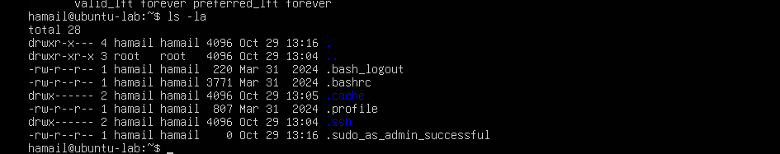
- Inspect these directories (run each command and screenshot the output):
ls -la /bin
- Save screenshot as ls_bin.png.

ls -la /sbin
- Save screenshot as ls_sbin.png
ls -la /usr
- Save screenshot as ls_usr.png.
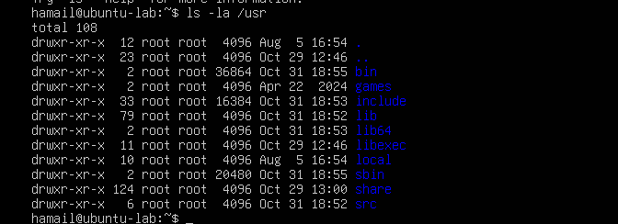
ls -la /opt
- Save screenshot as ls_opt.png.
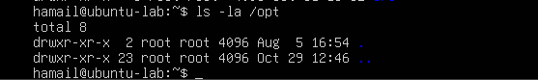
ls -la /etc
- Save screenshot as ls_etc.png.
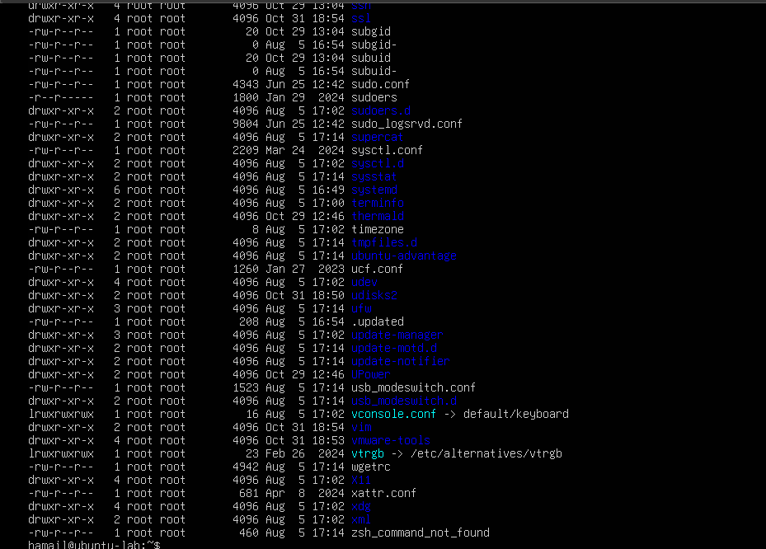

ls -la /dev
- Save screenshot as ls_dev.png.
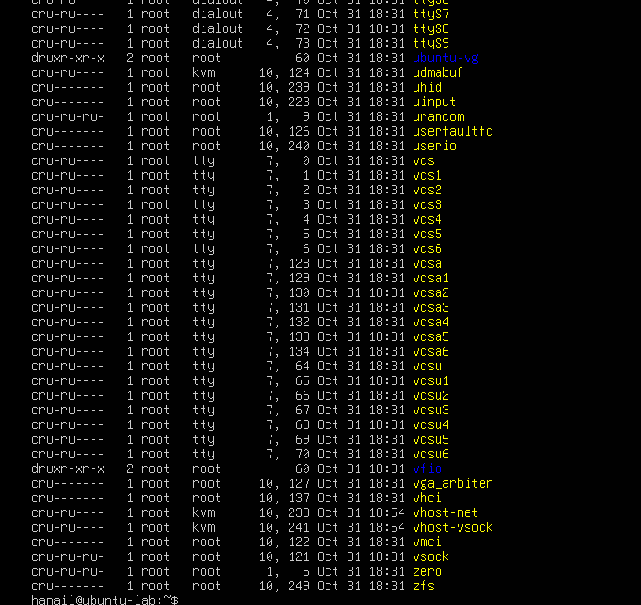
ls -la /var
- Save screenshot as ls_var.png.
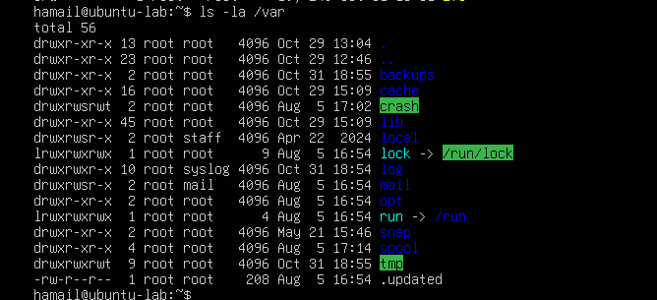
ls -la /tmp
- Save screenshot as ls_tmp.png.
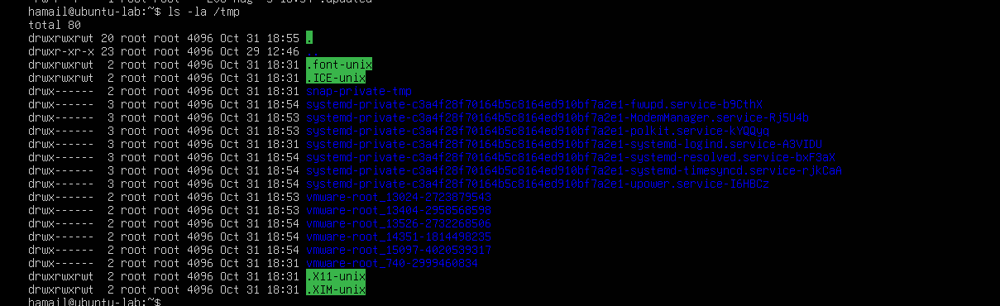
- List your home directory and show hidden (dot) files:
ls -la ~
- Save screenshot as: home_ls.png
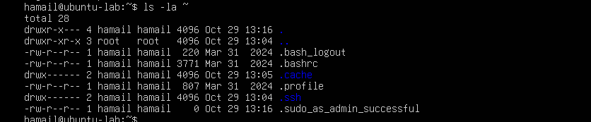

- Write a short paragraph (3–5 sentences) that explains the difference between /bin, /usr/bin and /usr/local/bin. Open your editor:
nano ~/answers.md
- Type the paragraph in the editor, save and exit.
- After saving, open the editor display (or show the file) and capture a screenshot of the paragraph. Save that screenshot as: answers_md.png
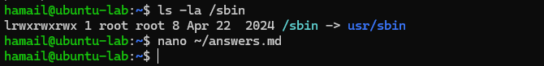

Task 4 – Essential CLI tasks — navigation and file operations
Practice basic commands used daily on Linux systems. Use screenshots only for evidence.
Steps (inside VM terminal)
- Create a workspace and navigate:
mkdir -p ~/lab4/workspace/python_project
- Save screenshot as mkdir_workspace.png.
cd ~/lab4/workspace/python_project
- Save screenshot as cd_workspace.png.
pwd
- Save screenshot as pwd_workspace.png.
- Create files using an editor (open each editor session and save a screenshot showing content):
nano README.md
- Inside nano add: Lab 4 README and save.
- Save screenshot of the editor after saving as nano_readme.png.
nano main.py
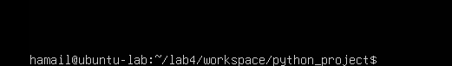
- Inside nano add: print("hello lab4") and save.
- Save screenshot as nano_main.png.
nano .env
- Inside nano add: ENV=lab4 and save.
- Save screenshot as nano_env.png.
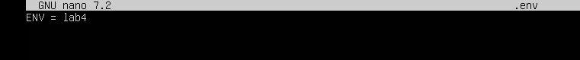
- List files and capture:
ls -la
- Save screenshot as workspace_ls.png.
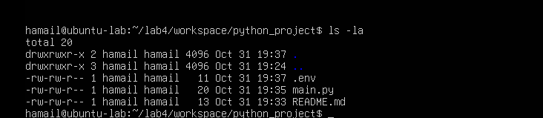
- Copy, move and remove:
cp README.md README.copy.md
- After running, save screenshot as cp_readme.png.
mv README.copy.md README.dev.md
- After running, save screenshot as mv_readme.png.
rm README.dev.md
- After running, save screenshot as rm_readme.png.
mkdir -p ~/lab4/workspace/java_app
- Save screenshot as mkdir_java_app.png.
cp -r ~/lab4/workspace/python_project ~/lab4/workspace/java_app_copy
- After running, save screenshot as cp_recursive.png.
ls -la ~/lab4/workspace
- Save screenshot as copy_verify.png.
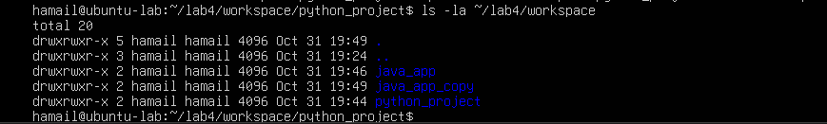
- Use command history and tab completion:
history
- Save screenshot as history.png.
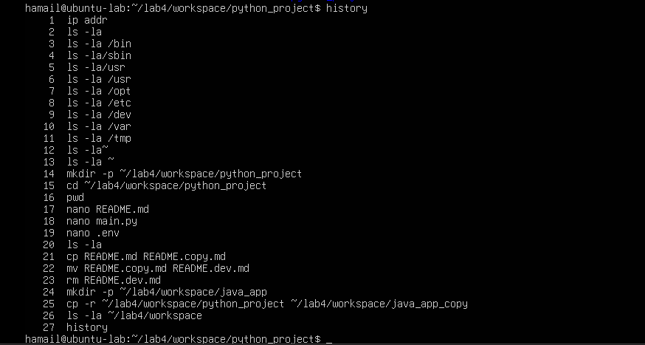
- Demonstrate tab completion (type partial name and press Tab) and capture that action as tab_completion.png.
Task 5 – System info, resources & processes
Collect system information and observe processes. Use screenshots only.
Steps (inside VM terminal)
- Kernel and OS:
uname -a
- Save screenshot as uname.png.
- CPU (ensure model name visible):
cat /proc/cpuinfo
- Save screenshot as cpuinfo.png.
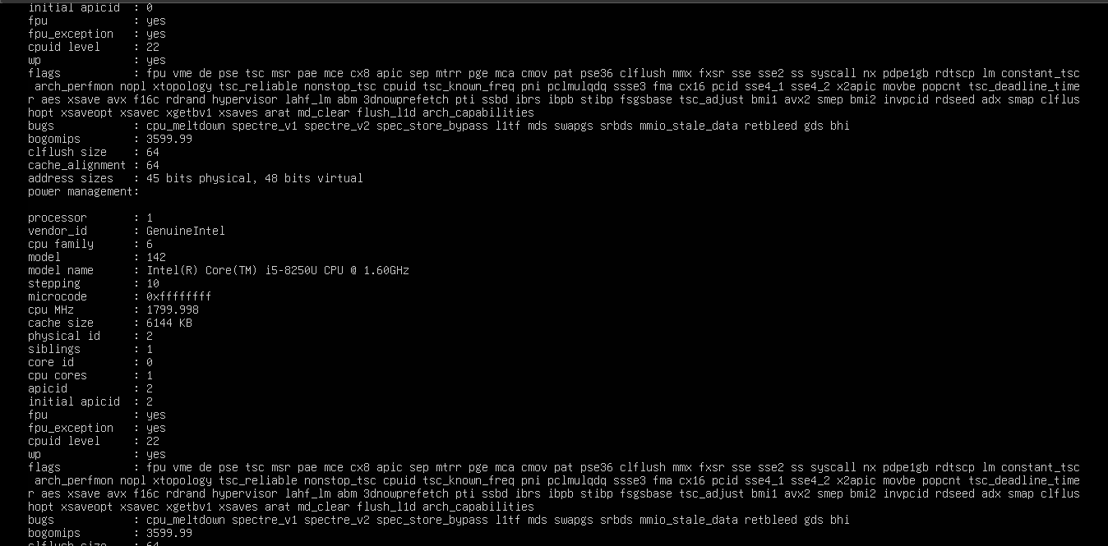
- Memory:
free -h
- Save screenshot as meminfo.png.
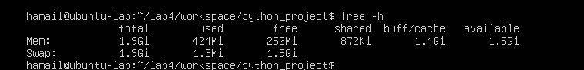

4.Disk:
df -h
- Save screenshot as diskinfo.png.
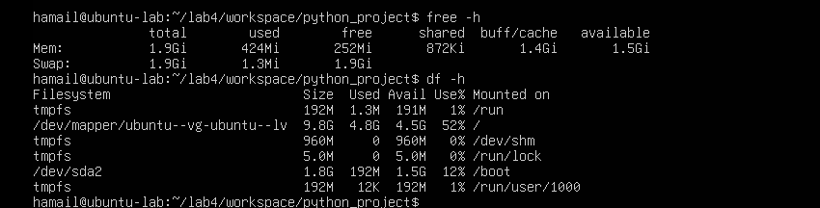
- View OS release information:
cat /etc/os-release
- Save screenshot as os-release.png.
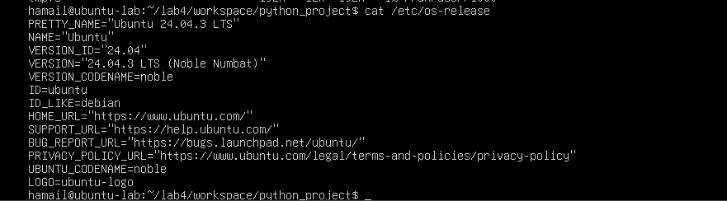
- Processes (show top lines of ps output):
ps aux
- Save screenshot as processes.png.
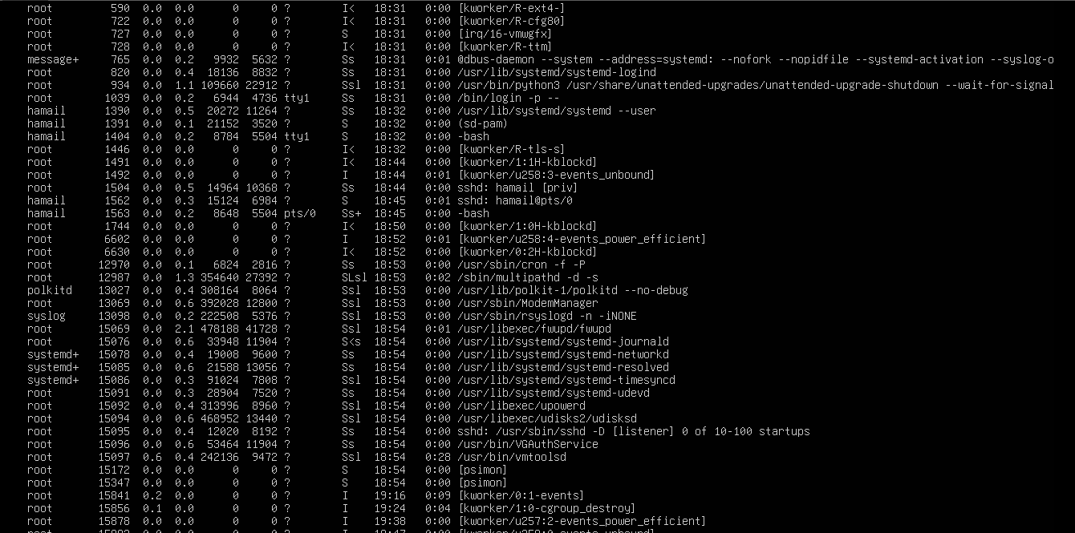

Task 6 – Users and account verification (no sudo group change)
Create a non-root user and verify the account exists. This task does NOT add the created user to the sudo group.
Steps (inside VM terminal)
- Create a new user named lab4user:
sudo adduser lab4user
- During prompts, capture the terminal and save screenshot as adduser_lab4user.png.
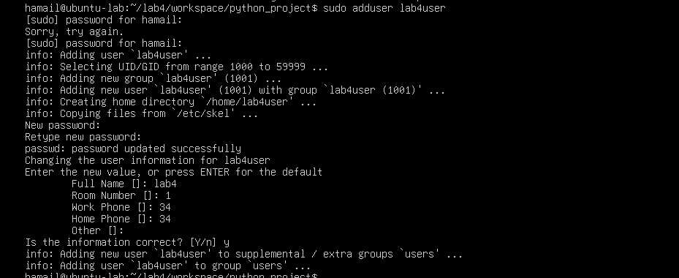
- Verify the user entry:
getent passwd lab4user
- Save screenshot as lab4user_passwd.png.
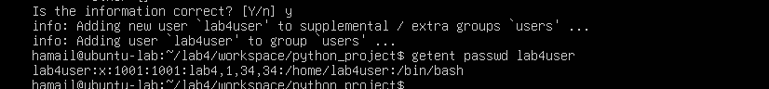
- Switch to the new user to verify login:
su - lab4user
- Save screenshot as su_lab4user.png.
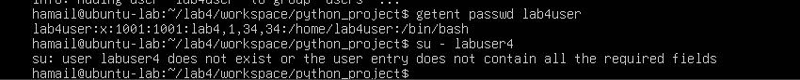
- From the new user you may attempt a sudo command to show that sudo is not available for this account (expected failure), e.g.:
sudo whoami
- Save screenshot as sudo_whoami.png.
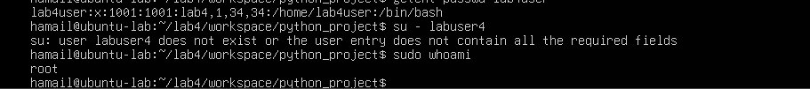
- Return to the original user:
exit
- Save screenshot as exit_back.png.
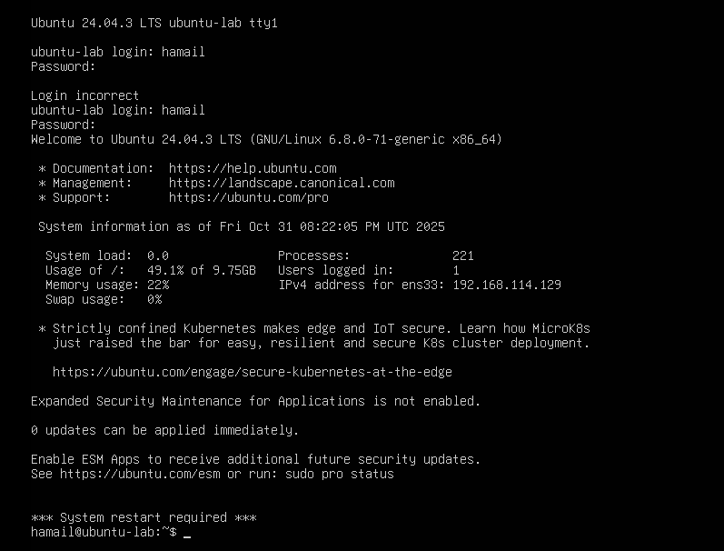
- (Optional) Remove the test user when finished:
sudo deluser --remove-home lab4user
- If run, save screenshot as deluser.png.
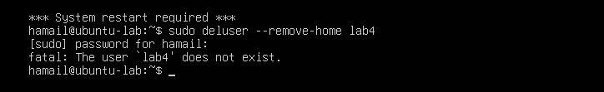
Bonus Task 7 – Create a small demo script using an editor and run it
This task is optional — complete it for extra practice or extra credit. It is not required for passing the core lab tasks.
Steps (inside VM)
- Open an editor to create the script:
nano ~/lab4/workspace/run-demo.sh
- Type the following lines into the editor (manually or paste), save and exit:
#!/bin/bash
echo "Lab 4 demo: current user is $(whoami)"
echo "Current time: $(date)"
uptime
free -h
- Save screenshot of the editor after saving the file as nano_run_demo.png.
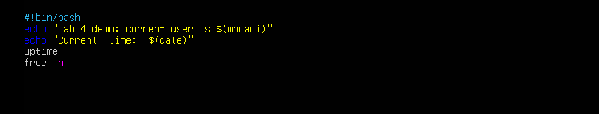
- Make the script executable:
chmod +x ~/lab4/workspace/run-demo.sh
- Save screenshot as chmod_run_demo.png.
- Run the script as your regular user:
~/lab4/workspace/run-demo.sh
- Save screenshot of the script output as run_demo_output.png.
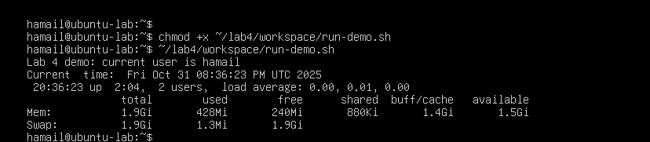
- Optionally run it with sudo:
sudo ~/lab4/workspace/run-demo.sh
- Save screenshot as run_demo_output_sudo.png.
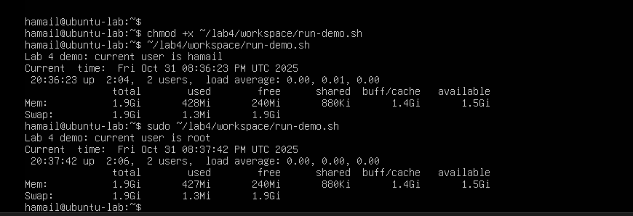
Exam Evaluation Questions
1. Remote Access Verification (Cyber Login Check)
Scenario:
You are part of a SOC (Security Operations Center) investigating unauthorized access to a Linux server hosted on VMware. Prove you can securely connect and verify your identity.
Steps:
- Connect to the Ubuntu VM remotely from your host terminal.
  - Screenshot as Q1_remote_connection.png

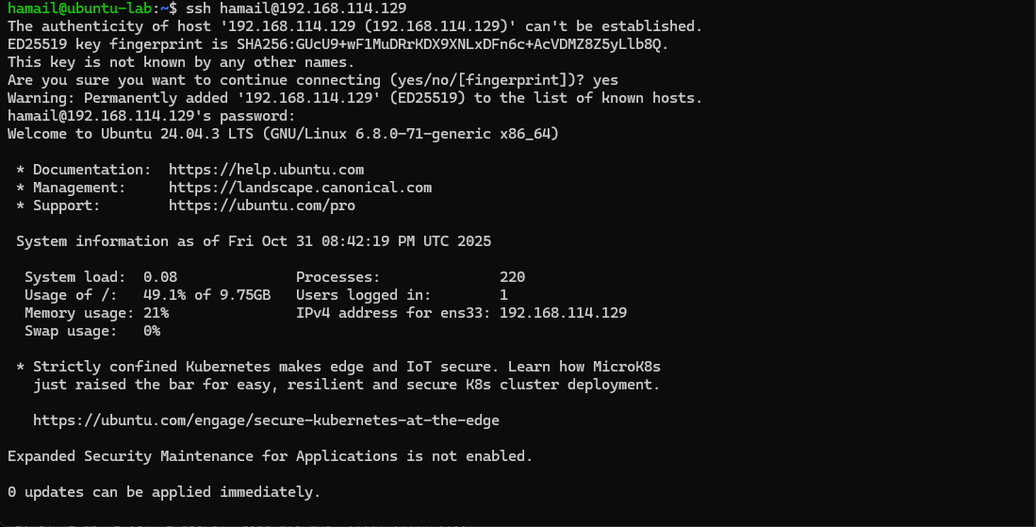
2.Verify your current user and home directory path.
  - Screenshot as Q1_user_verification.png
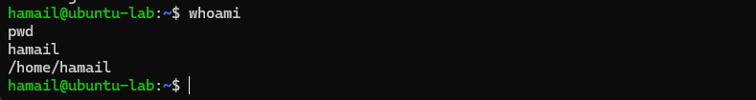
- Confirm you are connected to the correct host machine.
  - Screenshot as Q1_host_confirmation.png
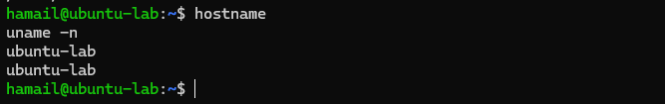

2. Filesystem Inspection for Forensic Evidence
Scenario:
The incident response team suspects malicious files in system directories. You must explore the filesystem to locate and document the system’s structure.
Steps:
- Display the contents of the root directory.
  - Screenshot as Q2_root_listing.png
- Display the OS version and release information.
  - Screenshot as Q2_os_version.png
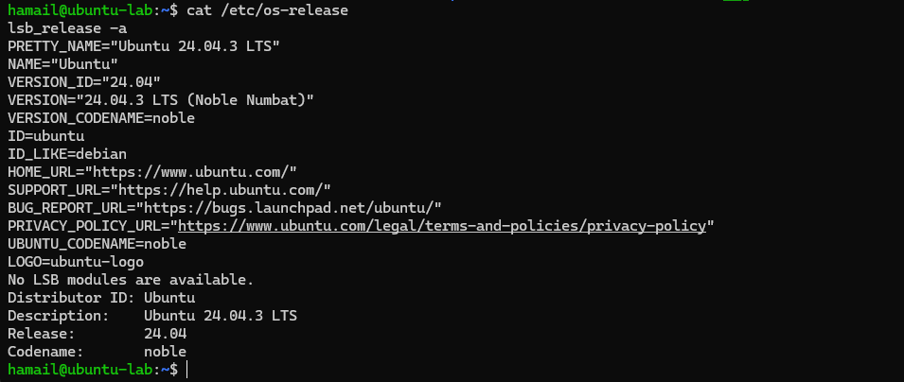
- Explore and record directory listings for /bin, /sbin, /usr, /opt, /etc, /dev, /var, and /tmp.
  - Screenshot as Q2_directory_evidence.png
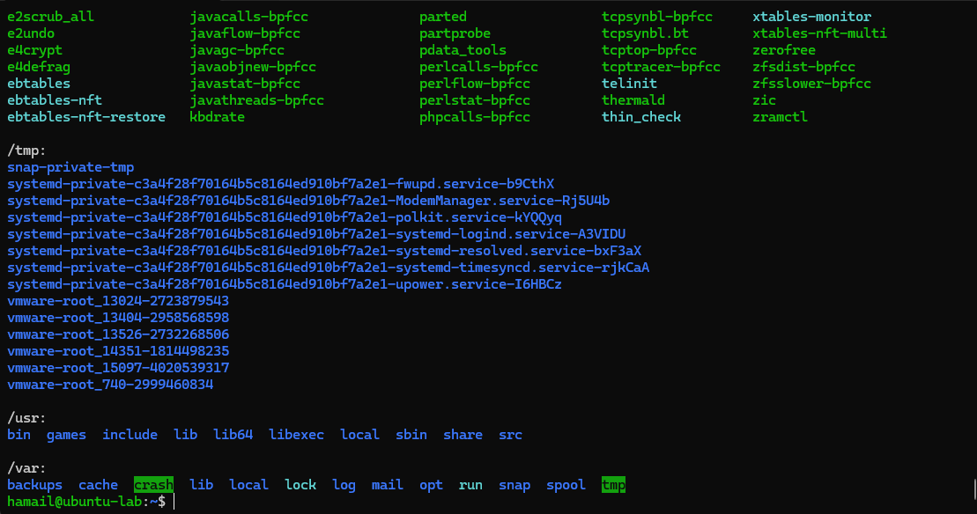
- Display all hidden files in your home directory.
  - Screenshot as Q2_hidden_files.png
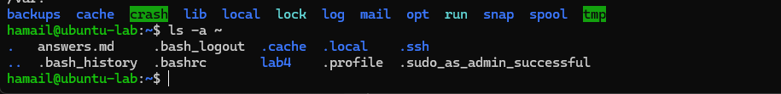
- Create a markdown file summarizing your findings on key binary directories.
  - Screenshot as Q2_report_file.png

3. Evidence Handling & File Operations
Scenario:
You are creating a sandbox environment to safely analyze and handle suspicious files collected from a compromised system.
Steps:
- Create a structured folder hierarchy under your home directory for analysis.
  - Screenshot as Q3_workspace_created.png
- Create three text files, including one hidden file, in your workspace.
  - Screenshot as Q3_files_created.png
- Create a backup copy of one file, rename it, and then delete it after verification.
  - Screenshot as Q3_backup_handling.png
- Copy the entire workspace as an evidence backup folder.
  - Screenshot as Q3_workspace_backup.png
- Display your command history to document all actions performed.
  - Screenshot as Q3_command_history.png
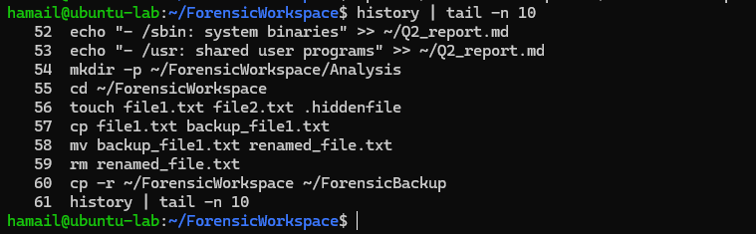
- Demonstrate Linux auto-completion by typing a partial command or filename.
  - Screenshot as Q3_autocomplete.png

4. System Profiling and Process Monitoring
Scenario:
You are investigating a potential malware infection that is consuming excessive resources on the Linux VM.
Steps:
- Display the system’s OS and kernel version for the investigation report.
  - Screenshot as Q4_system_info.png
- Display CPU, memory, and disk usage information.
  - Screenshot as Q4_resource_info.png
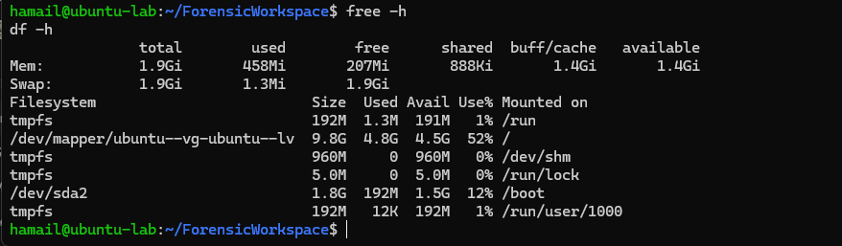
- Display all active running processes to identify suspicious activity.
  - Screenshot as Q4_process_list.png
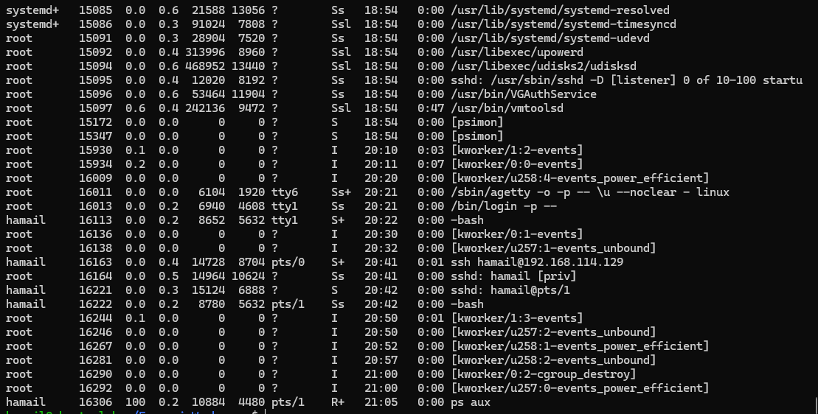

5. User Account Audit & Privilege Escalation Simulation
Scenario:
You are performing a user activity audit on a compromised Linux server.
The SOC suspects a newly created account (lab4user) may have been used for unauthorized access.
Your task is to simulate the account creation, perform privilege tests, and analyze authentication logs for forensic evidence.
Steps:
- Create a new test user named lab4user.
  - Screenshot as Q5_user_created.png
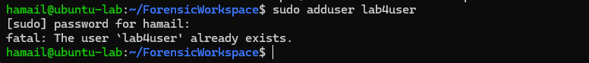
- Verify that the new user record exists in the system’s user database.
  - Screenshot as Q5_user_verified.png
- Log in as lab4user and confirm successful login.
  - Screenshot as Q5_user_login.png
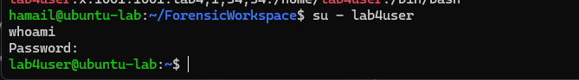
- Attempt to run an administrative command as lab4user (expect permission denied).
  - Screenshot as Q5_permission_denied.png
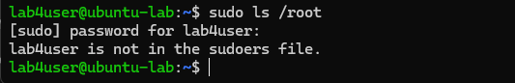
- Switch back to your main analyst account.
  - Screenshot as Q5_switch_back.png
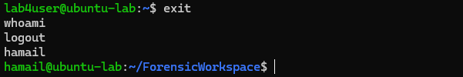
- Inspect the system authentication logs located at /var/log/auth.log to determine whether the lab4user account attempted any logins (successful or failed).
  - Screenshot as Q5_authlog_analysis.png
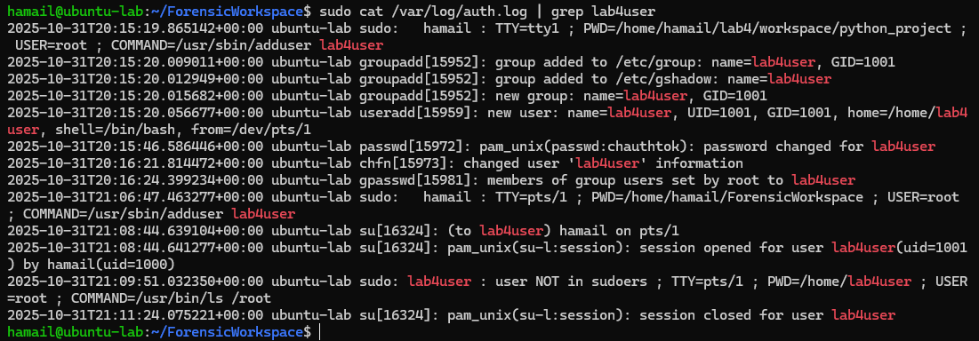
- (Optional) Remove the lab4user account after the audit and verify deletion.
  - Screenshot as Q5_user_removed.png
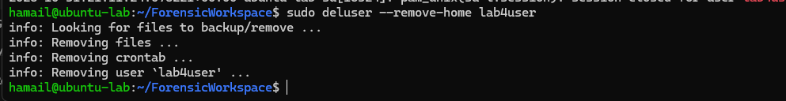

Reminder:
Take a screenshot after every step and name it as shown above. Include all screenshots in your submission for full credit.
Summary
In this lab you:
- Verified VM configuration in VMware Workstation.
- Logged into the existing Ubuntu Server VM using the Windows host terminal and explored the filesystem.
- Practiced core Linux CLI commands for navigation and file manipulation (evidence via screenshots).
- Collected system and process information and created a non-root user account without granting sudo.
- (Optional) Wrote and executed a simple demo script using an editor.

Submission
- Upload a Word file and PDF or .md file containing:
  - Step outputs or terminal screenshots for each task
  - Your answers to the hands-on practical exam questions
  - workspace/ — folder containing files you created in the workspace:
    - README.md, main.py, .env (required)
    - run-demo.sh (optional / bonus)
  - screenshots/ — folder containing all required screenshots listed above (preferred), including answers_md.png

